**JS Applications Exam – UniEnt SPA**

You are assigned to implement a **Single** **Web Application** (SPA) using HTML5, JavaScript, AJAX, REST and JSON with cloud-based backend (Firebase, Backendless or other). Using libraries like **Handlebars** and **Sammy** is allowed but is not obligatory. The app keeps **users** and **events**. **Guests** should be able to **register** and **login**. Logged-in users should be able to view **all events**, **create** **events**, **join events**, see **details** about a **event** and **logout**. Logged-in users should also be able to **edit** or **delete** the events **they have created**. There should also be a **section** where users can **see only the events they have created**.

## Create a REST Service

Use any cloud-based databaseand create application to keep your data in the cloud.

Create a collection called **events.** Each **event** has a **name**, **date**, **description**, **organizer** and **people interested in** (starting from 0).

## Create CookUni Application

**UniEnt – HTML and CSS**

You have been given the web design of the application as **HTML** + **CSS** files.

* Initially all views and forms are shown by the HTML. Your application may **hide**/**show elements** by CSS (display: none) or **delete**/**reattach** from and to the DOM all unneeded elements, or just display the views it needs to display.
* You may render the views/forms/components with **jQuery** or **Handlebars**.

**Important**: Don’t change the elements’ **class names** and **ids**. Don’t rename form fields/link names/ids. You are **allowed** to add **data attributes** to any elements. You may modify href **attributes** of links and add action**/**method **attributes** to **forms**, to allow the use of a routing library.

**UniEnt – Client-Side Web Application**

**Design** and **implement** a client-side front-end app (SPA) for managing **events**. Implement the functionality described below.

**Notifications (5 Pts)**

The application should notify the users about the result of their actions.

* In case of a **successful** action, a **notification message** **(green)** should be shown, which disappears automatically after 5 seconds or manually when the user clicks it.



* In case of **error**, an **error notification message (red)** should be shown, which disappears on user click.



* During the **AJAX calls** a **loading notification message (blue)** should be shown. It should disappear automatically as soon as the AJAX call is completed.



* **NOTE**: You get all the points if **all** the notifications have the **exact content** as described in each section above.

**Navigation Bar (5 Pts)**

Navigation links should correctly change the current page (view).

* Clicking on the links in the **NavBar** should display the view behind the link (views are represented as sections in the HTML code).
* Your application may **hide**/**show elements** by CSS (display: none) or **delete**/**reattach** from and to the DOM all unneeded elements, or just display the views it needs to display.
* The Logged-in user navbar should contain the following elements: Icon (icon.jpg) which is a **link** to the Home page, [Organize Event], the user caption ("{username}"), [Logout].
  + The user caption should be a link that navigates to the **currently logged in user’s** **profile**.



* The guest users navbar should contain the following elements: : Icon (icon.jpg) which is a **link** to the Home page and [Login].



**Home Page (Guest) (5 Pts)**

The initial page (view) should display the **guest** **navigation bar** ("Home" (icon) and "Login") + **Guest Home Page** + Footer.

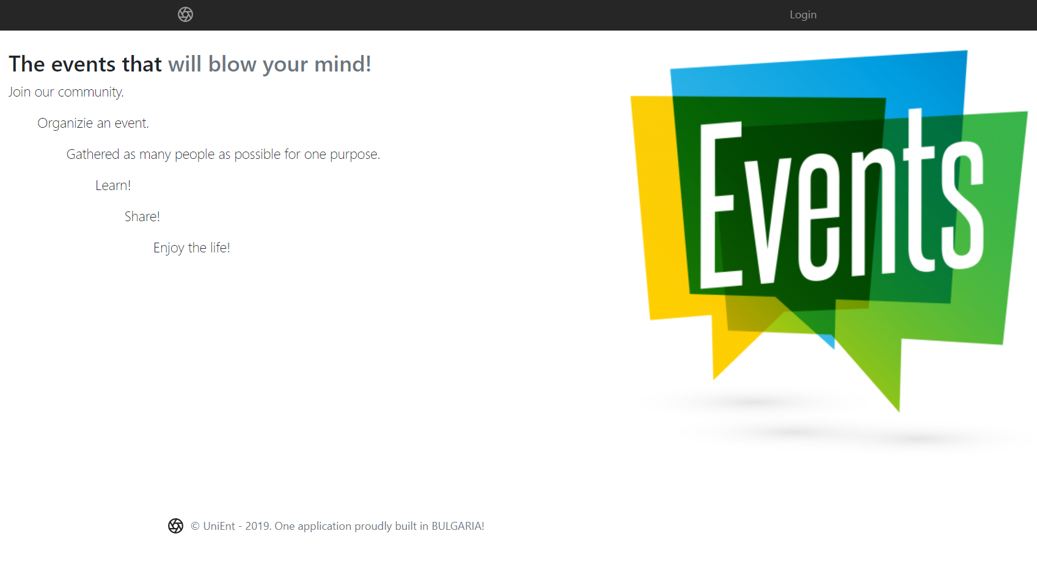

**Register User (5 Pts)**

By given **username** and **password,** the app should register a new user in the system.

* The following validations should be made:
  + The **username** should be **at least 3 characters** long
  + The **password** should be **at least 6 characters** long
  + The **repeat password** should be **equal to the password**
* After a **successful registration**, a notification message **"User registration successful."** should be displayed and the app should **redirect** to the **home page with the right navbar**.
* In case of **error** (eg. invalid username/password), an appropriate error **message** should be displayed, and the user should be able to **try** to register again.
* Keep the user session data in the browser's **session storage**.

Register once and create/join awesome events!

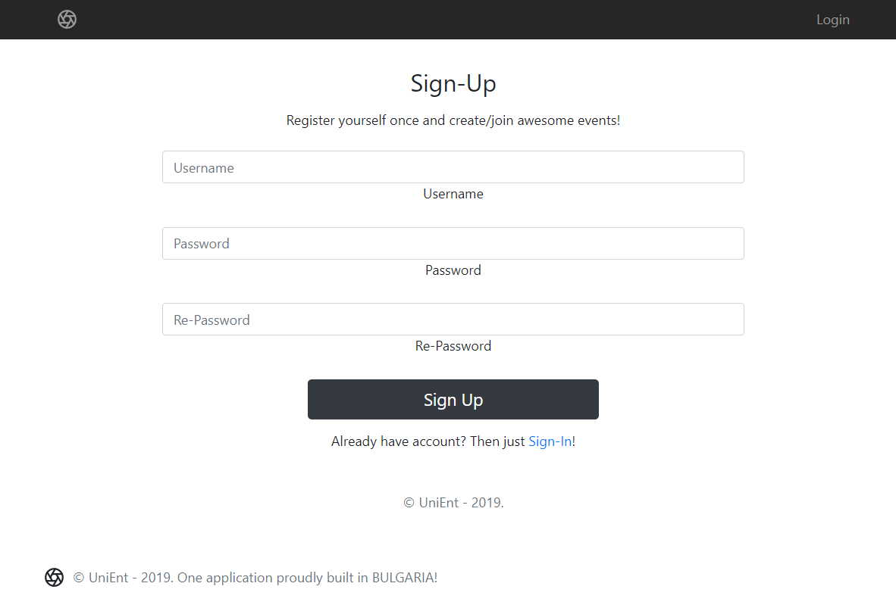

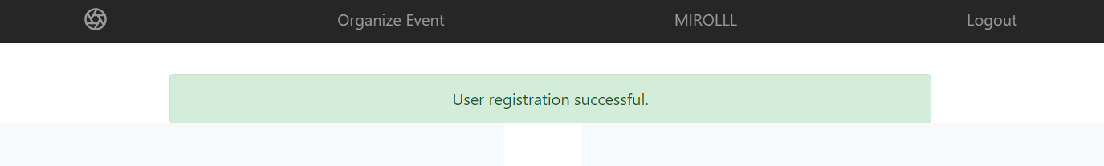

**Login User (5 Pts)**

By given **username** and **password,** the app should login an existing user.

* After a **successful login**, a notification message **"Login successful."** should be shown and the user home screen should be displayed.
* In case of **error**, an appropriate error message should be displayed and the user should be able to fill in the login form again.
* Keep the user session data in the browser's **session storage**.
* Clear **all** input fields after a **successful** login.

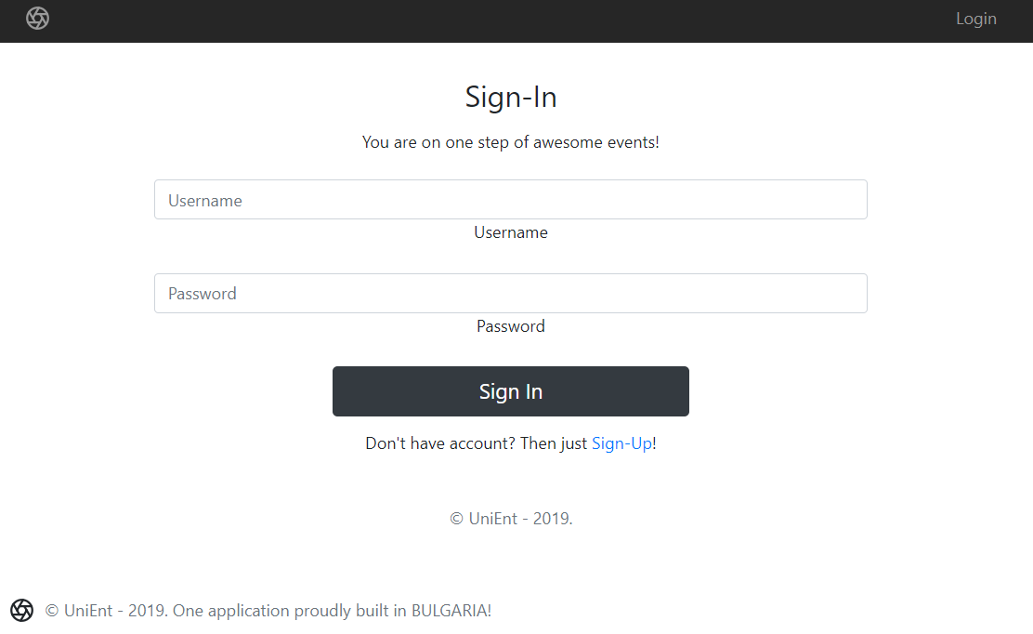

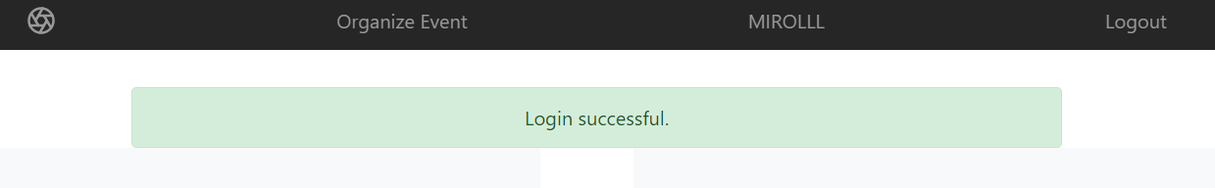

**Logout (5 Pts)**

Successfully logged in users should be able to **logout** from the app.

* After a **successful** logout, a **notification** message **"Logout successful."** should be displayed and the **anonymous screen** should be shown
* The **"logout" REST service** at the back-end **must** be called at logout
* All local information in the browser (**user session data**) about the current user should be deleted

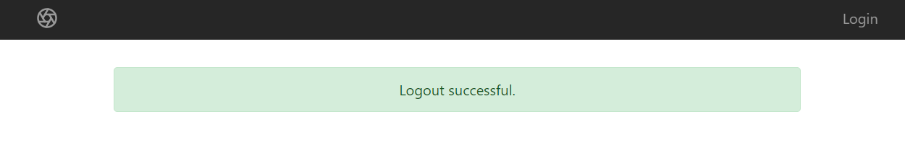

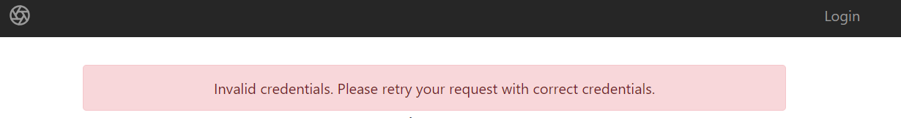

**Home Page (30 Pts)**

Successfully logged-in users should be welcomed by the Homepage. They should be able to see all created (organized) events.

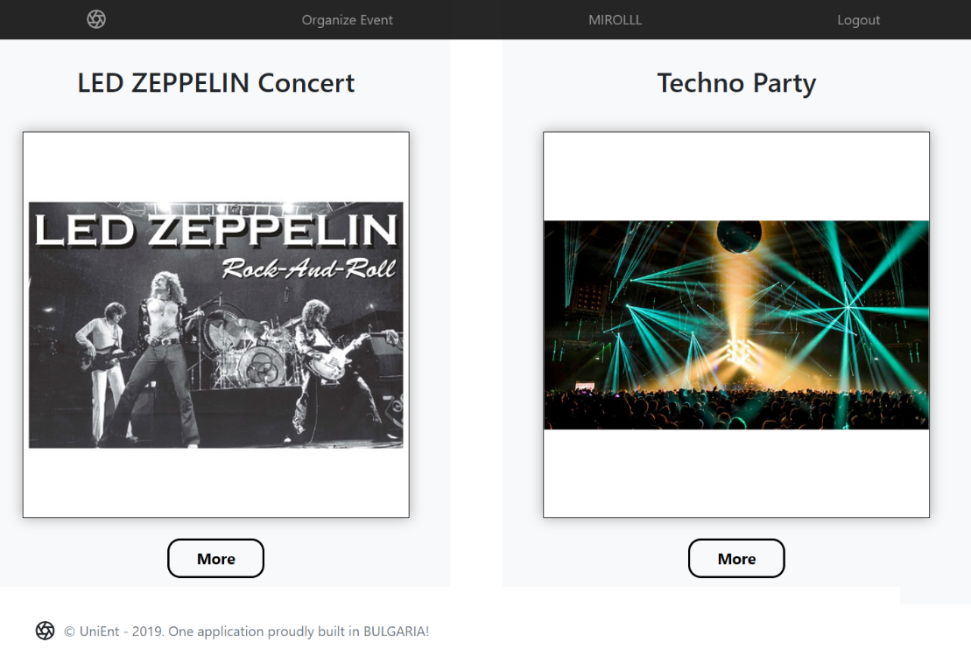

If there are **NO** such events, the following view should be displayed:

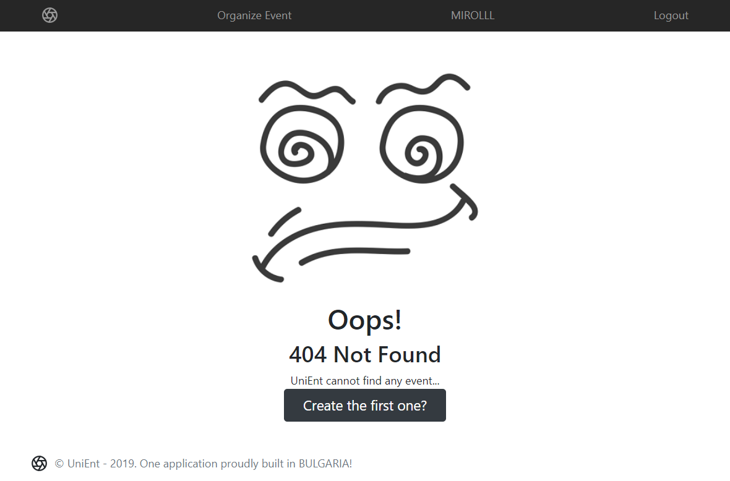

[**Create the first one?**] **button** should refer to the **organize** **event** **form**

**Organize Event (10 Pts)**

Logged-in users should be able to **Create (organize)** events.

Clicking the [Organize Event] **link** in the **NavBar** should **display** the Organize Event page.

* The form should contain the following validations:
  + The **event** **name** should be **at least 6 characters** long.
  + The **date** should be in **string** format (24 February; 24 March - 10 PM;).
  + The **description** should be **at least 10 characters** long.
  + The **image** should start with **"http://"** or **"https://"**.
  + **By** **default**, every newly created event must have additional information:
    - **Organizer:** string representing the current event creator;
    - **People interested in:** number starting from 0;
  + After a **successful** event creation, a notification message **"Event created successfully."** should be displayed and the Home pageshould be shown.
* The inputs fields in the form **should be cleared.**
* The newly organizer event should be stored in the database collection "events".

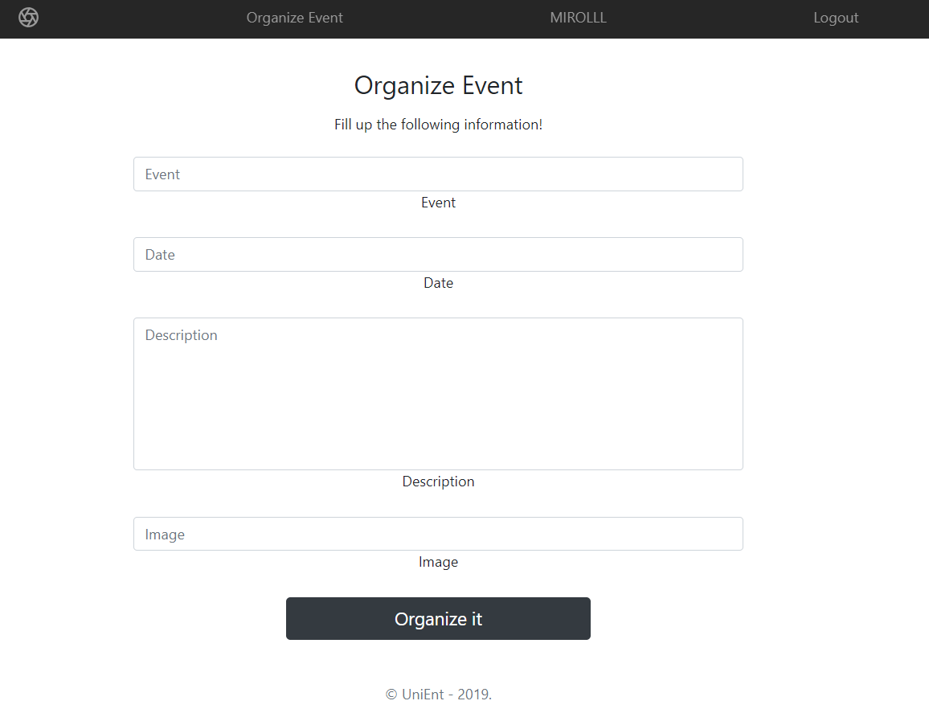

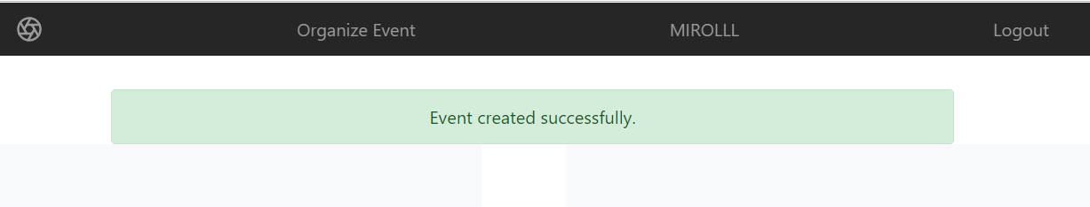

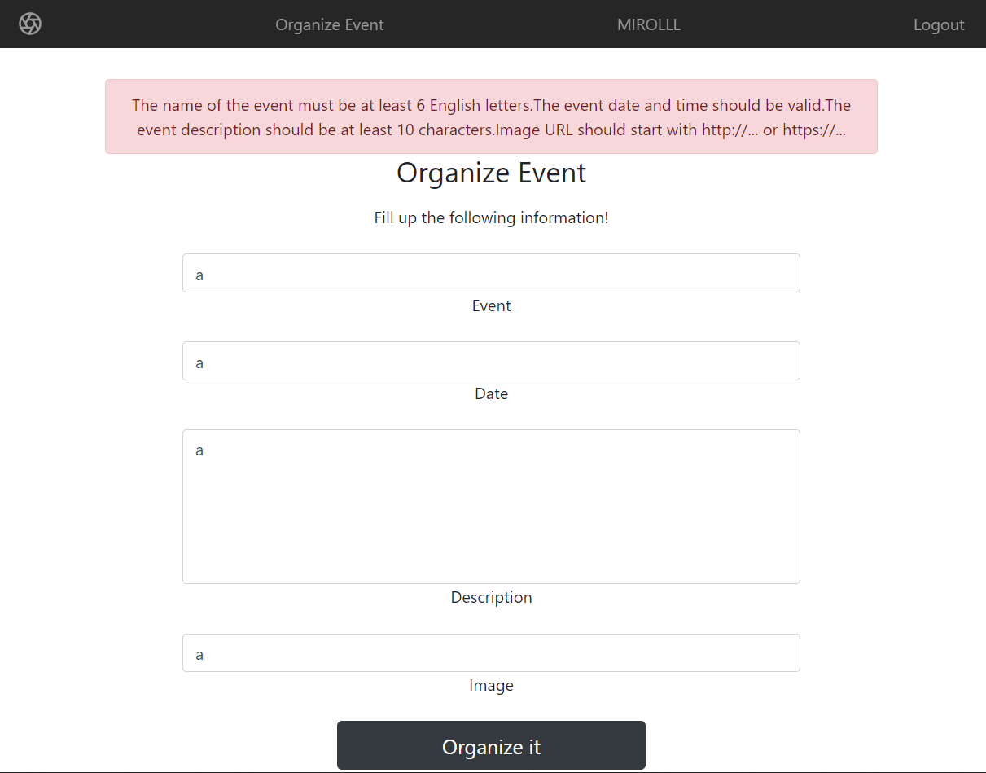

**Details Event (5 Pts)**

Logged-in users should be able to **view details** aboutevents.

Clicking the [More] **link** in of a **particular event** should **display** the Event Details page.

* If the currently logged-in user is the organizer of the event, the [Edit] and [Close] **buttons** should be set to **visible**, otherwise there should be only 1 button [Join].

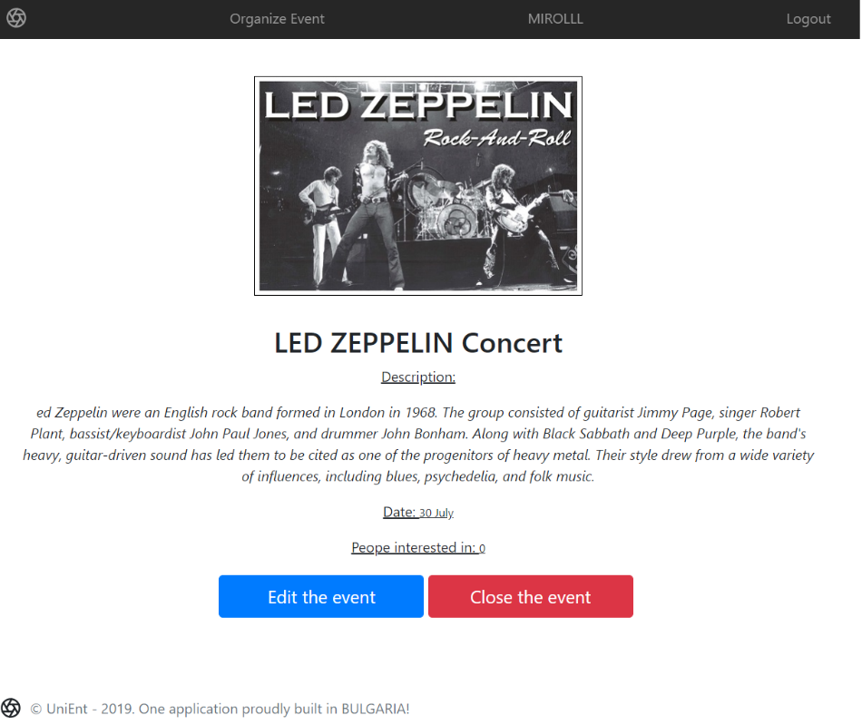

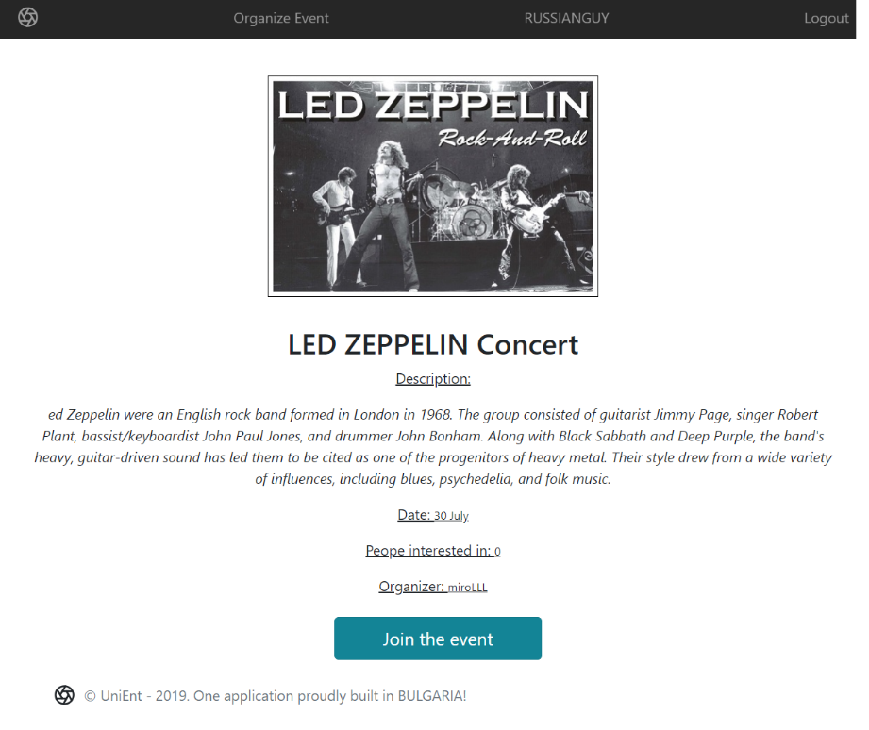

**Edit Event (5 Pts)**

Logged-in users should be able to **edit** their **own** events.

Clicking the [Edittheevent] **link** of a **particular event** on the Event Details page should **display** the Edit Event page:

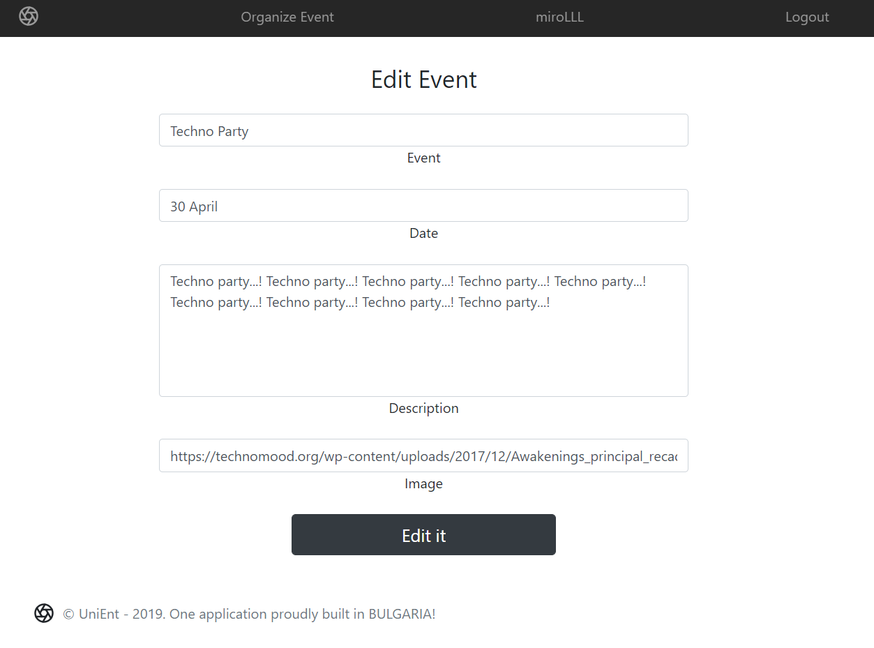

* After a **successful edit**, a notification message "Event edited successfully." should be **displayed**, and the user should be redirected to the Home page.

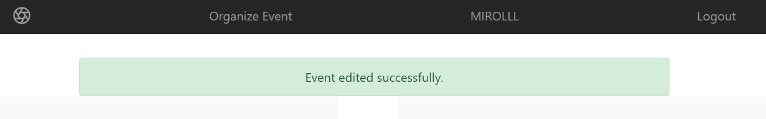

**Join Event (5 Pts)**

Logged-in users should be able to **Join** events, organized by **other** **users**.

**NOTE**: A user should **NOT** be able to join an **event**, organized by **himself**.

Clicking the [Join the event] **link** of an **event** (on the Event Details page) should **increase** the property for the **people interested in** the corresponding event.  
Users can **join events** multiple times**.**

* After **successfully joining** an **event**, a notification message **"You** **join** **the** **event successfully."** should be displayed.

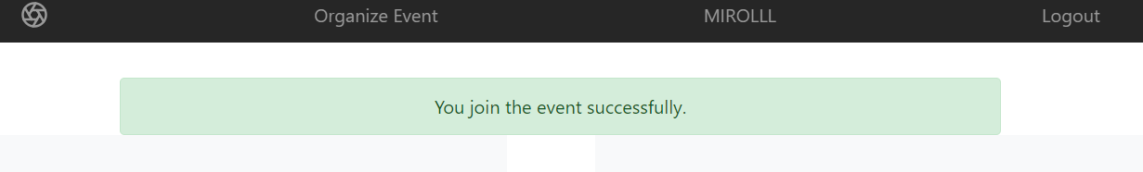

**Delete Event (5 Pts)**

Logged-in users should be able to **delete their** events.

Clicking the [Close the event] **link** of an **event** (on the Event Details page) should **delete** the **event**.

* After **successful** **event delete** a notification message **"Event** **closed** **successfully."** should be displayed and the Home pageshould be **shown**

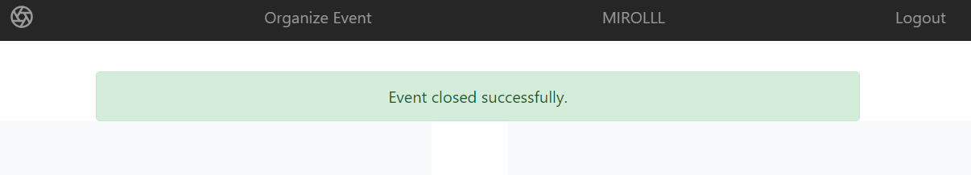

**User Profile (10 Pts)**

Logged-in users should be able to **view their** **profile**.

Clicking the **user caption** ({USERNAME}) **link** on the **navigation bar** should **display** the   
User Profile page:

* Each user profile should display user info - **profile picture**, **username** and **organization information**
  + **"**Organizer of {count} events"
  + The **names** of **all events** which the user has **organized**.

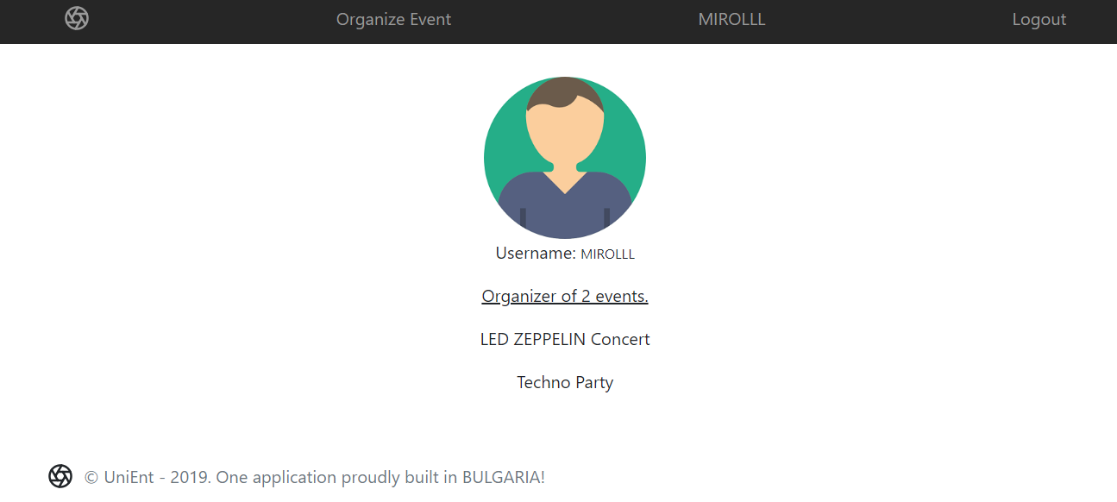

* In case of **no events**, display "No events".

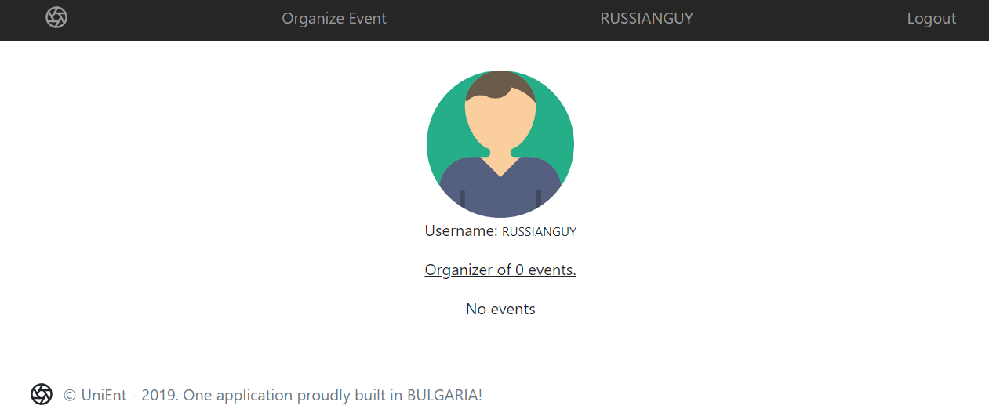

**(BONUS) Sorting: (5 Pts)**

The events in the **home** **page** (for **registered** users), should be sorted in **descending** order by **people interested in.**

## Submitting Your Solution

Exclude the node_modules folder and ZIP your project. Upload the archive to Judge system.

<https://judge.softuni.bg/Contests/Compete/Index/1645#0>